Angular Framework

Angular is a framework used to develop single page applications using HTML & Typescript.

Single Page Applications are applications that makes user to see everything in one page, it only loads part of the page instead of reloading the complete page whenever user interacts with the application.

Ex: Gmail, Facebook, GitHub, Angular.io, ...

Angular uses component to render the data, components are UI’s which can be independently built and reused in other components. They are build without knowing where it will be displayed

Ex: Facebook has Profile component, that can be reused in comments, likes, newsfeed and so on.

Angular uses HTML & Typescript to develop the application.

HTML: It is used display the content

Typescript: It is used to write logics in angular, like fetching the data from server and passing the data to the HTML, deciding what components to be loaded and so on.

Typescript is a super-set of Javascript, it is less error prone compare to javascript, Typescripts are compiled to javascript.

* Typescript more safe compare to javascript
* It supports all the features of Javascript, including the new features of Javascript (released by ES6 in 2015)
* ES means EcmaScript which is a standard or specification for Javascript, ES is not a programming language, however Javascript implements the ES standard

Softwares required for Angular application development

* Visual Studio Code - Editor
* Node.js - Runtime environment to run javascript code & also angular code
* Angular CLI - toolkit for angular applications

ES6 features:

There are few new features added that simplifies javascript coding

* let, const, class, constructor keywords
* template strings
* arrow functions
* rest & spread operators

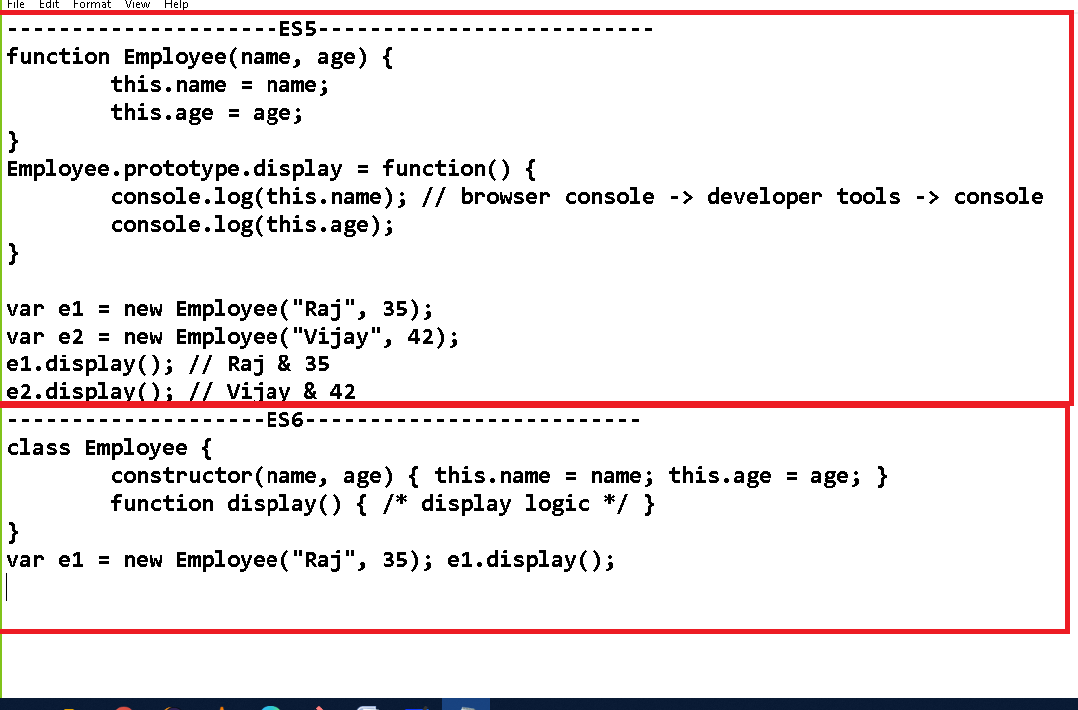

Creating function & object in ES5

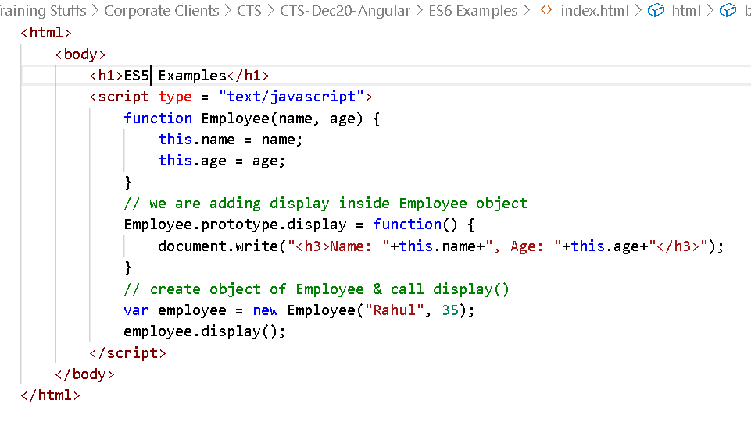

Output:

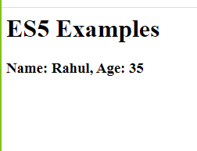

ES6 uses class & constructor keywords

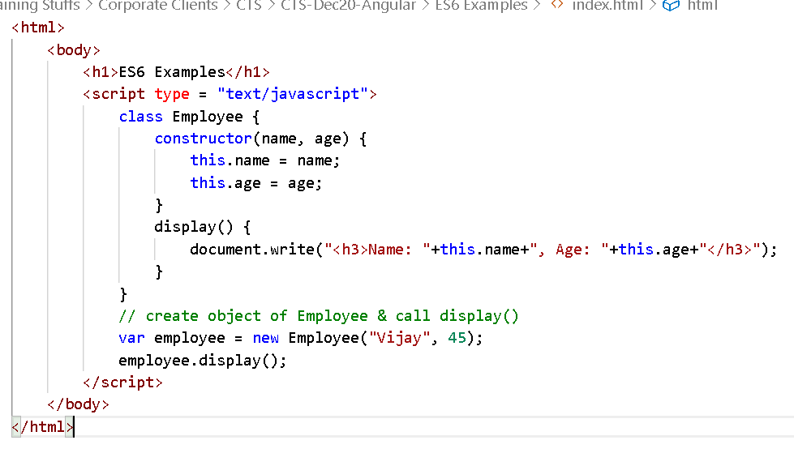

Output:

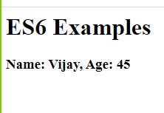

let, const keywords: these are used to create block scoped variables, because in javascript you were creating variable with ‘var’ which is not part of any scope.

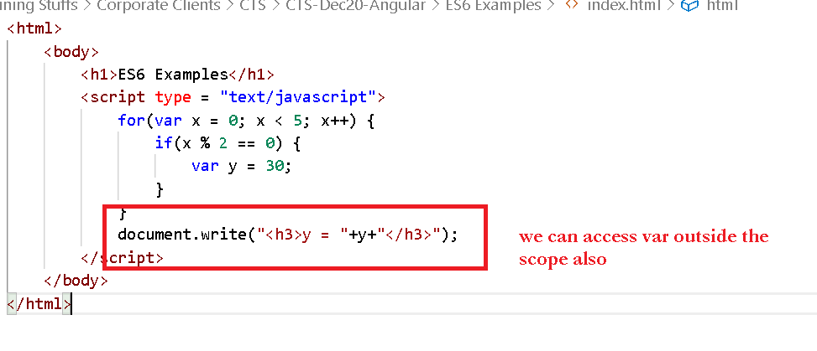

But with let & const you can create block scope variables

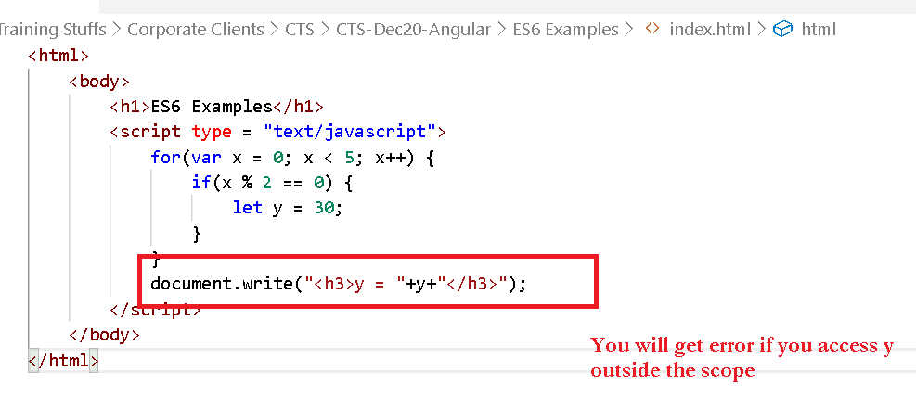

Template String

It allows you to create a string & access the data without breaking the strings using + operator.

Template strings uses a backtick(`) i.e., a quote below the Esc key.

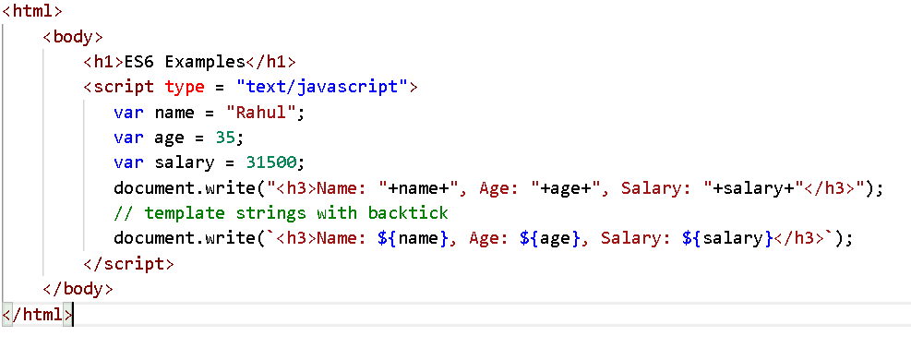

Output:

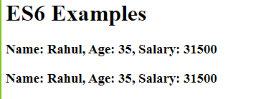

You can’t give line break without + in “ or ‘ quotes but you can give line break in ` without + operator

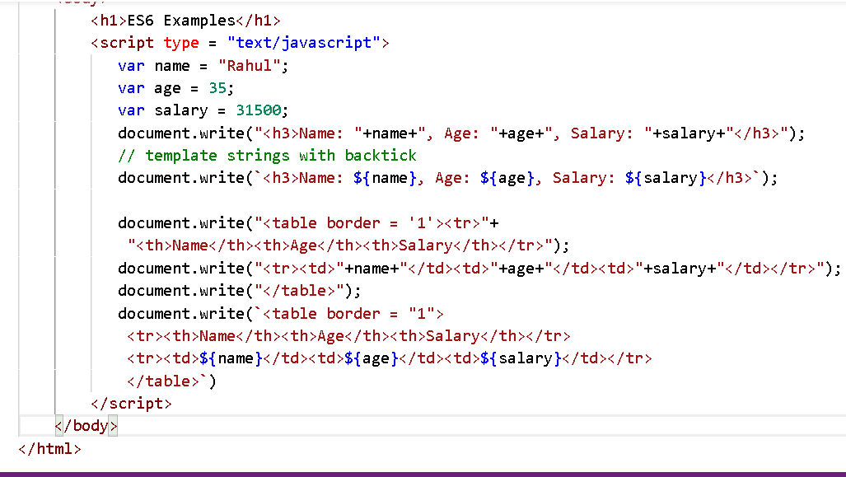

Output:

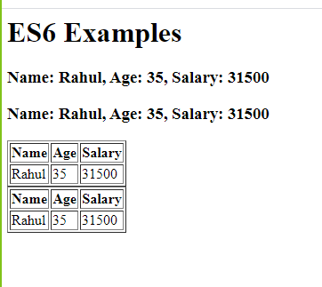

Arrow functions(=>):

These simplifies writing anonymous functions in javascript where they are having few lines of expressions.

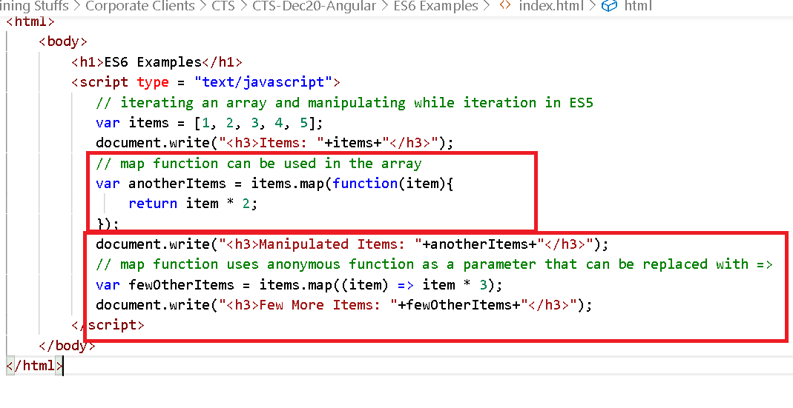

Output:

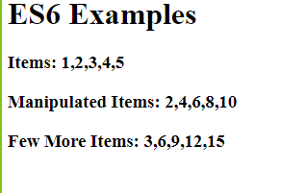

Rest & Spread operators

When a function doesn’t have an idea how many parameters are supplied by a caller you can have rest operator, and also when an input has to be spread across multiple parameters of a function you can use spread operator.

add(4, 3, 1, 2);  
add(4, 3);  
add();

Rest operator:

function add(...x) { .... }

The add function takes test parameter means can accept any number of parameters from 0 to many

function test(a, ...b) { ...}

The test function takes 1 parameter minimum followed by 0 or many parameters

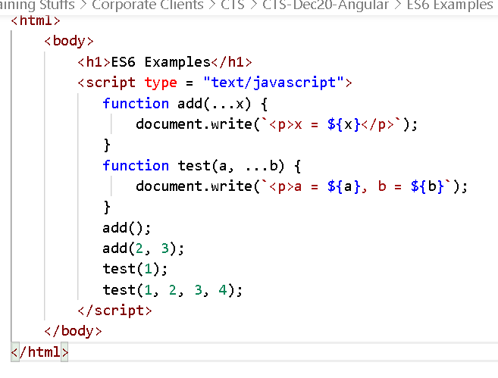

Output:

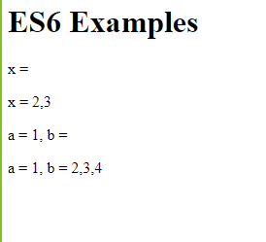

Spread operator

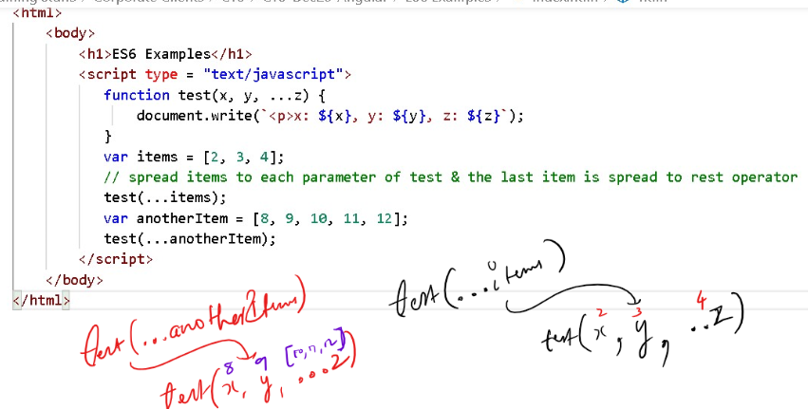

Output:

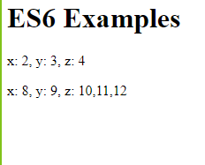

Typescript: It is a super-set of javascript, which supports all the javascript features including that it has some additional features

1. types for variables
2. return types for methods
3. short-cut initialization of constructor
4. import & exporting classes

Installing Angular Toolkit:

Command: *npm install -g @angular/cli*

How to create angular project

Command: *ng new my-first-app*

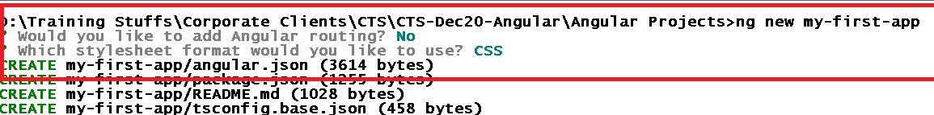

How to launch the application

Command: *ng serve*

How to add a component in another component

Angular gives you a command to generate the component, if you use this command it will automatically create 4 files

1. component class ts file
2. component html file
3. component css file
4. component spec file (testing purpose)

Updates the Application that component is created

Command: *ng generate component <<component-name>> (or)*

*ng g c component-name*

How to change the port

*ng serve --port=4201*

Angular Building Blocks:

These forms the angular application, the are:

1. Components: @Component({})
2. Modules: @NgModule({})
3. Pipes: |
4. Data-binding
5. Directives: ngFor, ngIf, ngSwitch
6. Services: @Injectable()
7. Routers: Navigations

Inline template

It is going to provide content in the @Component() decorator itself instead of a separate html file i.e, templateUrl.

@Component({  
 template: ‘content’  
})

hello.component.ts

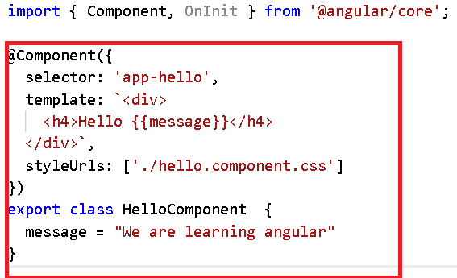

Add app-hello in root component

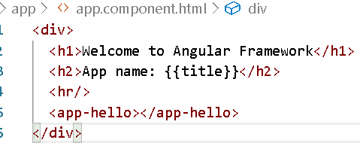

Output:

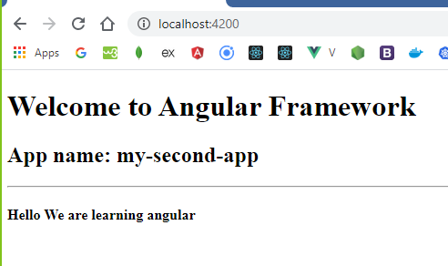

Different way of maintaining the data

Since you are using typescript, you can mention types

title : string = ‘string value’

employee : any = {“id”:1000, “name”:”Raj”}

employee : Employee = new Employee(1000, “Raj”);

employee : Employee[] = [array of employee objects]

hello/hello.ts

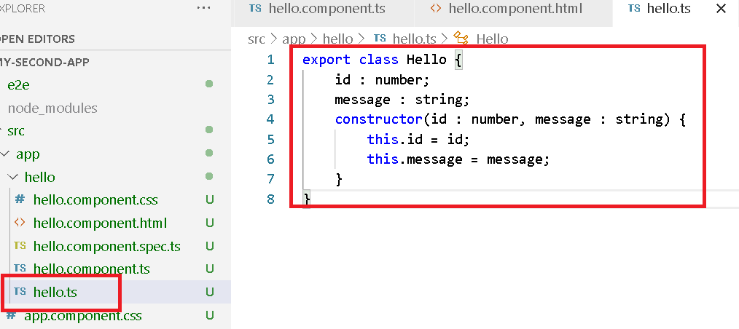

You should import Hello from hello.ts using

import { Hello } from ‘./hello’

hello/hello.component.ts

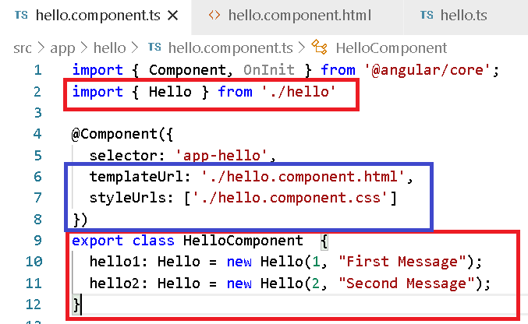

hello/hello.component.html

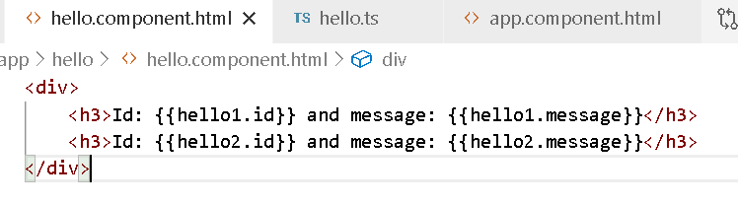

Output:

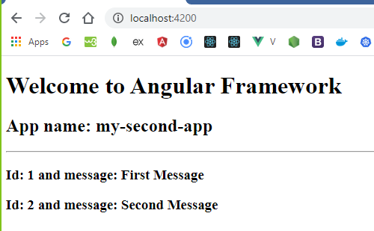

Angular Pipes(|):

It is used to format the output, we have many inbuilt pipes like

* uppercase
* lowercase
* date
* json
* currency

We can also create custom pipes by implementing PipeTransform interface & decorating it with @Pipe({})

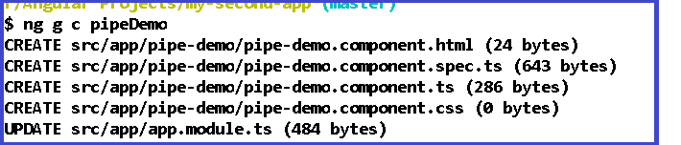

pipe-demo.component.ts

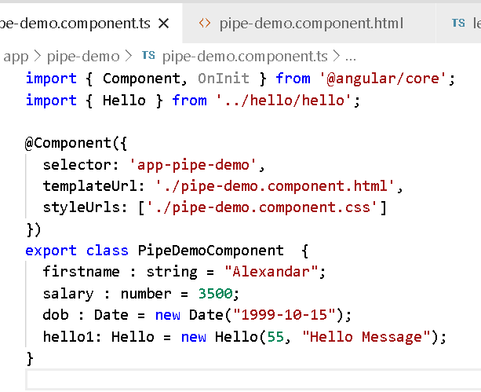

pipe-demo.component.html

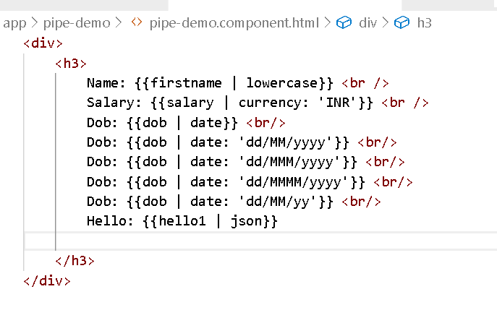

Output:

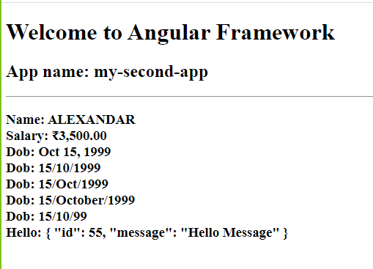

You can create custom pipe by using *ng g p pipe-name*

The above command creates a class that implements PipeTransform & decorate it with @Pipe({})

This will update the app.module.ts

We can also create pipe without using command as below

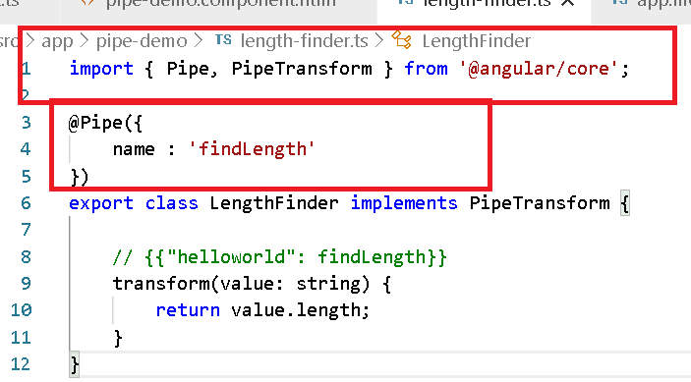

Since we created custom pipe manually we must update it in app.module.ts -> declarations property.

app.module.ts

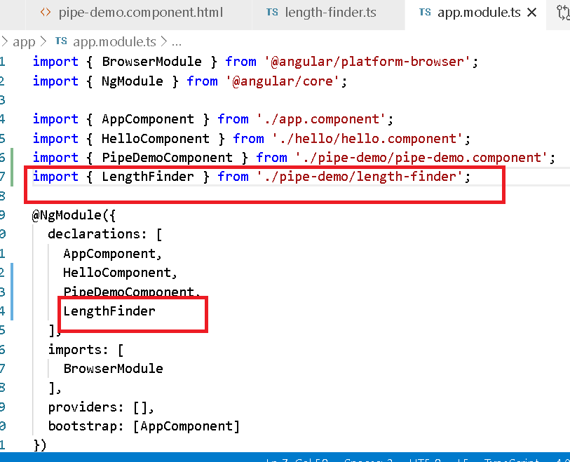

Now you can use this pipe name called ‘findLength’ in any html template

pipe-demo.component.html

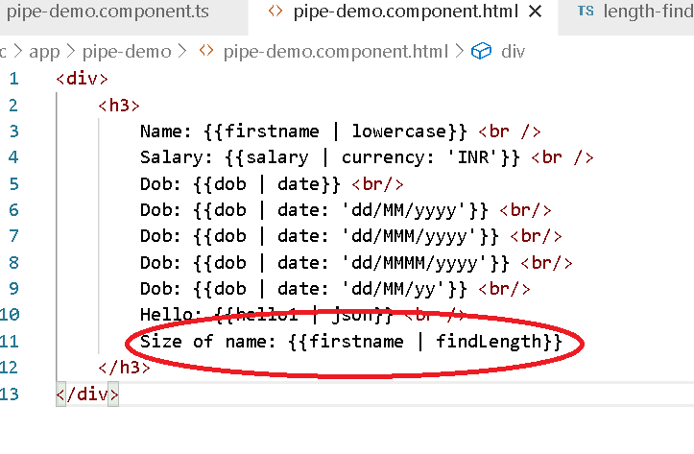

You can create any number of pipes in the same file but you need to have @Pipe for each class & mention them in the app.module.ts

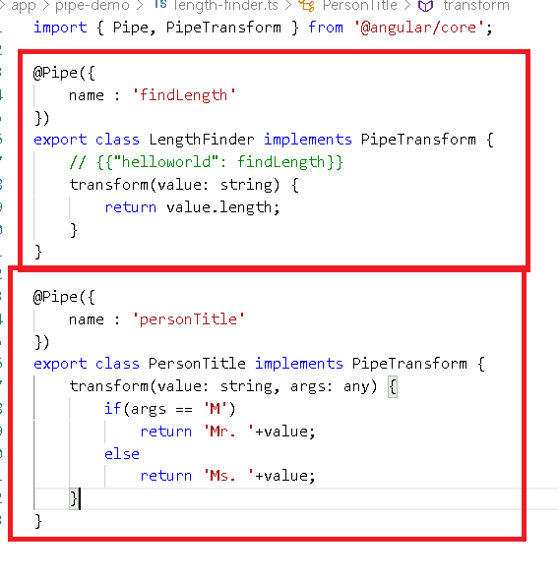

Note: transform(value, args), means {{value | pipeName : args}}.

app.module.ts

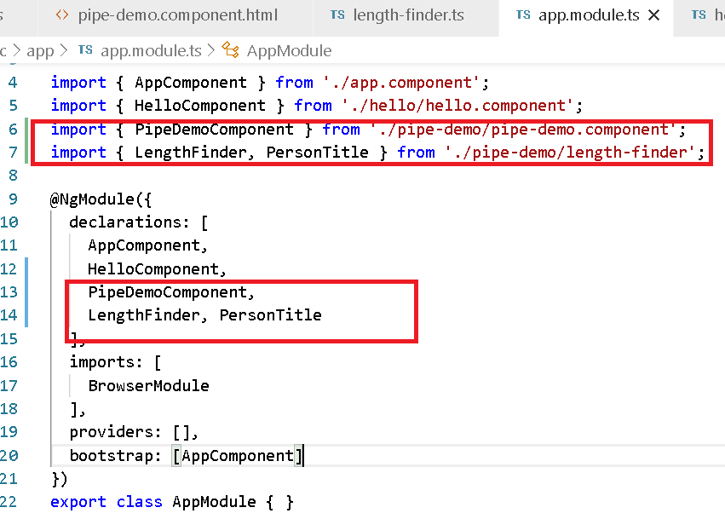

pipe-demo.component.html

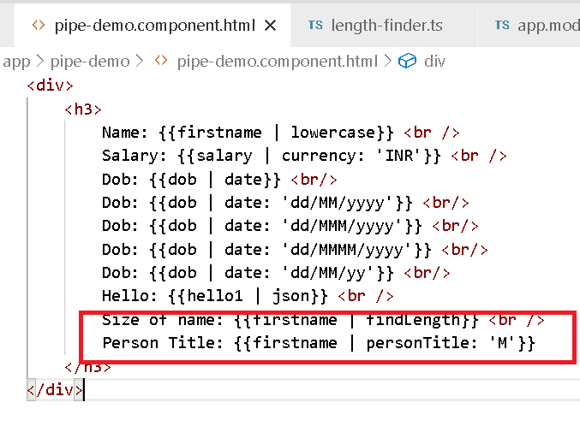

Note: Here ‘M’ is passed in html directly which is not proper way of mentioning the firstname is a male, so we must render Mr. or Ms. based on the data coming from component

Output:

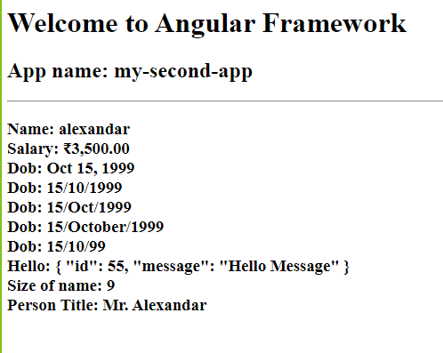

pipe-demo.component.ts

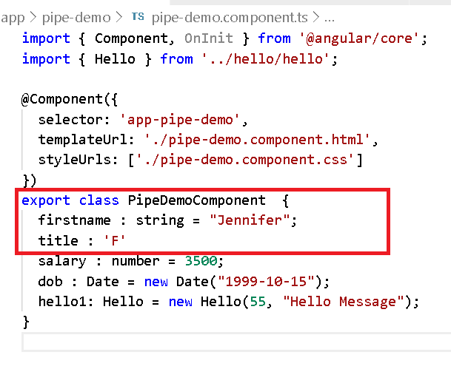

pipe-demo.component.html

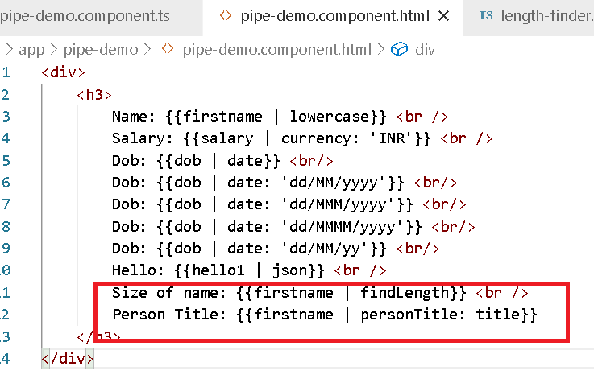

Note: You can also generate the pipes using ng g p pipe-name

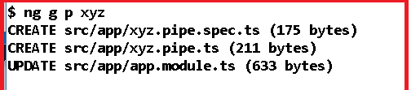

The above command gives you all the necessity to use pipes and directly you can implement transform().

Exercise:

Create a StudentComponent that will have Student data like rollno, name, marks.

* create 3 students with different marks like 30, 50, 80
* show all the 3 student data with marks, but use a pipe called result that will calculate the marks and displays pass, fail and firstclass

Structural Directives:

* *ngFor
* *ngIf

These directives is used to modify the DOM structures

*ngFor: It is used to iterate over the arrays and display items

*ngIf: It is used to apply conditions to display the content

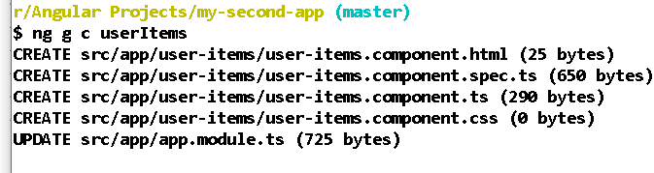

NgIf Demo

user-items.component.ts

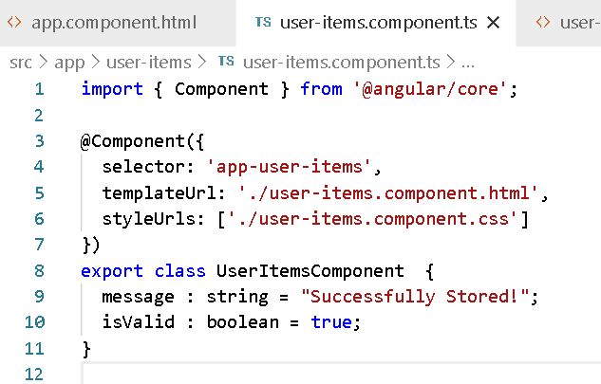

user-items.component.html

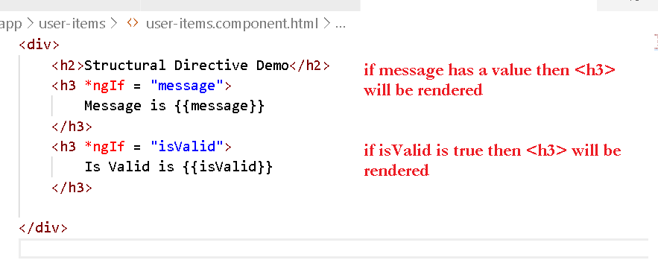

Output:

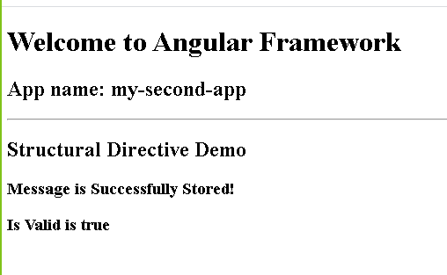

NgFor: This is used to iterate over the array and dynamically structure the DOM.

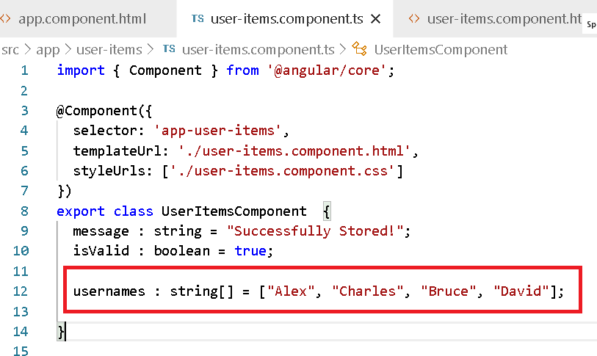

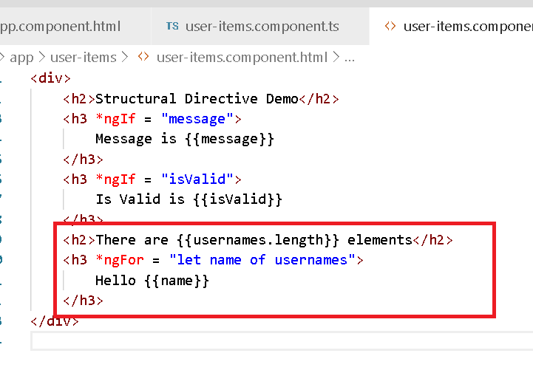

Output:

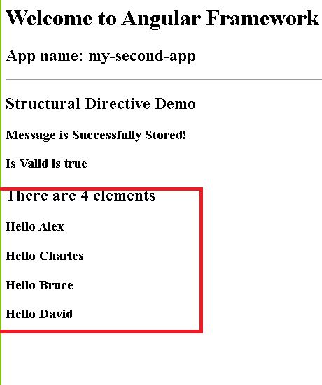

With NgFor you can create table rows dynamically

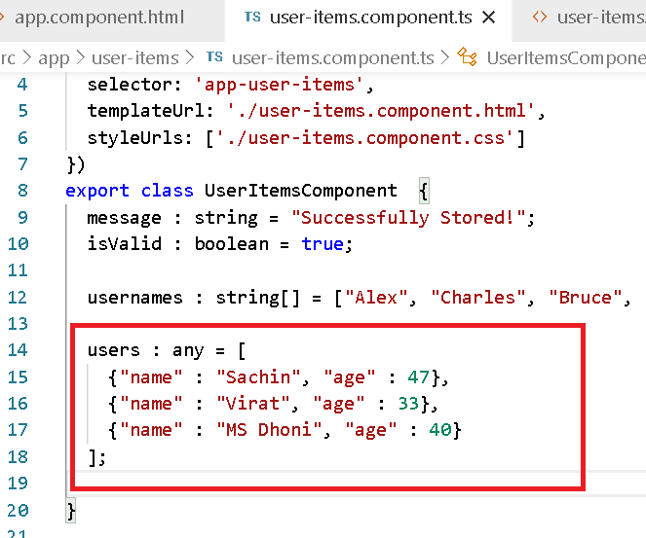

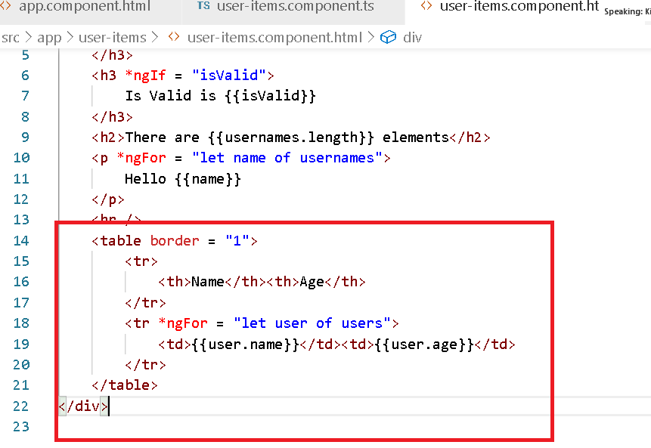

Output:

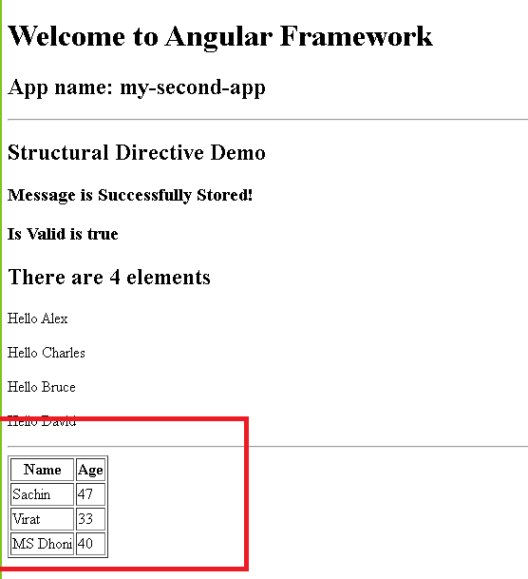

Exercise:

Try to display the below data in a table

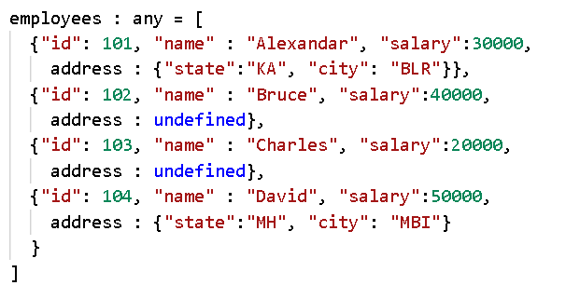

You have to have a table with totally 5 columms

|  |  |  |  |  |
| --- | --- | --- | --- | --- |
| Id | Name | Salary | State | City |
| 101 | Alexandar | 30000 | KA | BLR |
| 102 | Bruce | 40000 |  |  |
| 103 | Charles | 20000 |  |  |
| 104 | David | 50000 | MH | MBI |

Databinding:

It binds the data between the view & the component to enable the data to flow between them.

We have four types data binding to make the data to flow between the view & the component

1. Interpolation: Component -> View {{}}
2. Event Binding: View -> Component (eventName)
3. Property Binding: Component -> View [property]
4. Two way databinding: Component <-> View [(ngModel)] -> ngModel by default wouldn’t be available it is part of FormsModule that must be mentioned in your AppModule imports section

Event Binding

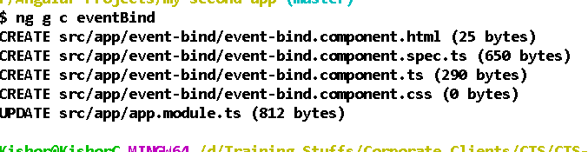  
event-bind.component.ts

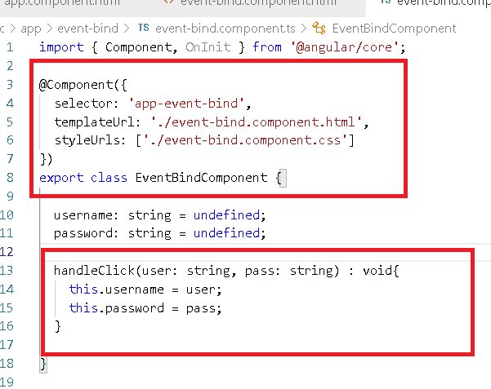

event-binding.component.html

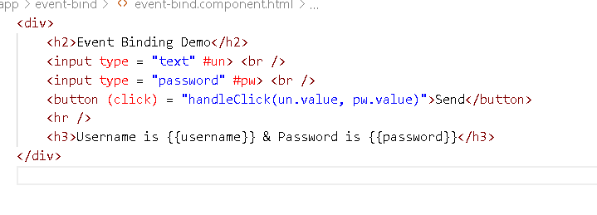

app.component.html

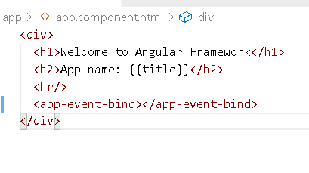

Output:

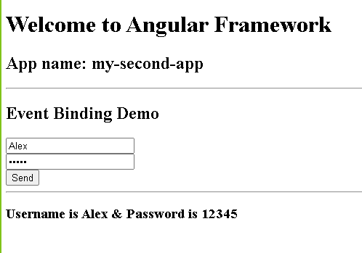

There are different types of events you can handle

1. (click): when you click on an element
2. (input): when you enter input to the input element
3. (ngSubmit): when you submit the form
4. (mouseEnter) & (mouseLeave): when you place cursor over the element
5. (keyUp) & (keyDown): when key is pressed/released

Property Binding: [propertyName]: C -> V

This is related to DOM properties, where you can hide/show the dom element or enable or disable the dome elements, here the data flows from component to view.

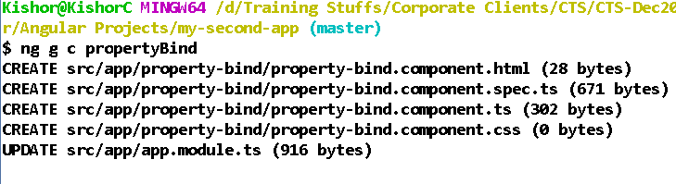

property-bind.component.ts

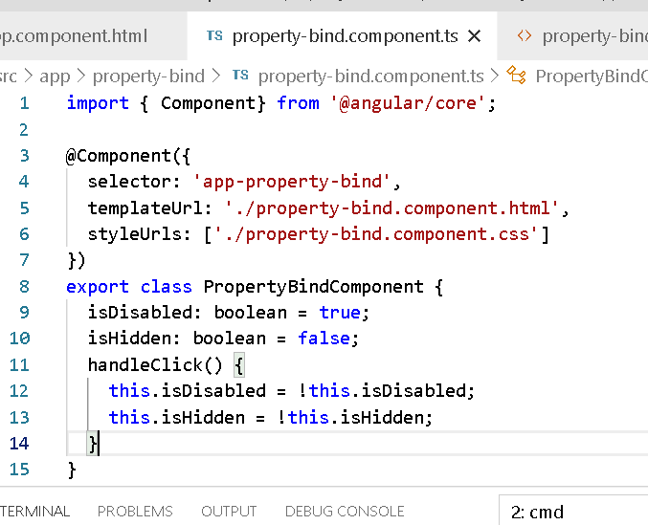

property-bind.component.html

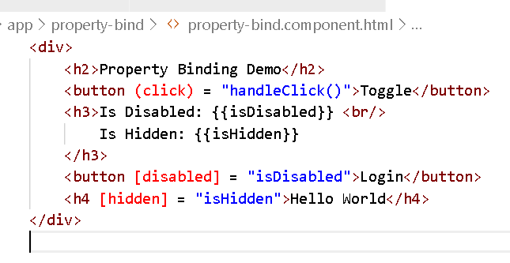

app.component.html

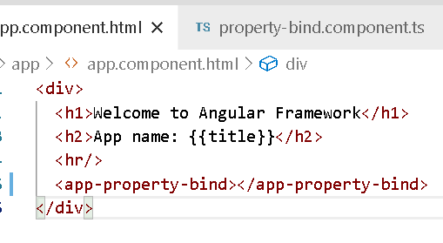

Output:

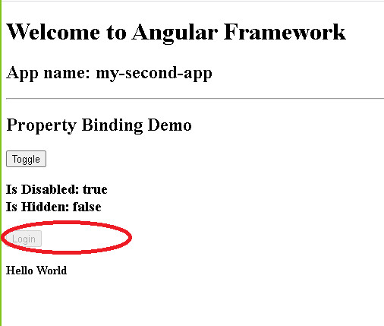

Two way databinding [(ngModel)]:

Here the data flow happens in both the directions i.e., from view to component & vice versa.

Here it automatically binds the data without explicitly binding each variable with event binding

By default ngModel is not added in your application hence you must use FormsModule in your application (AppModule) to use the ngModel

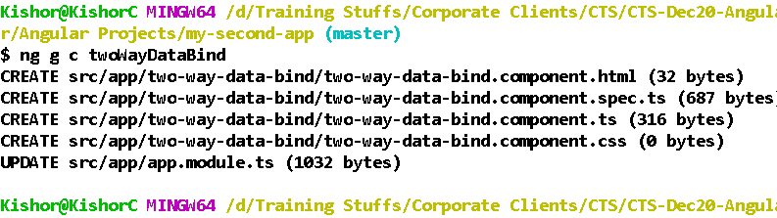

two-way-data-bind.component.ts

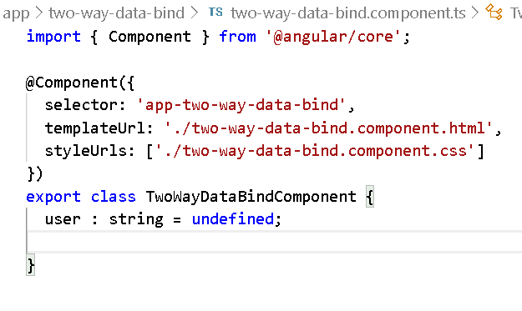

two-way-data-bind.component.html

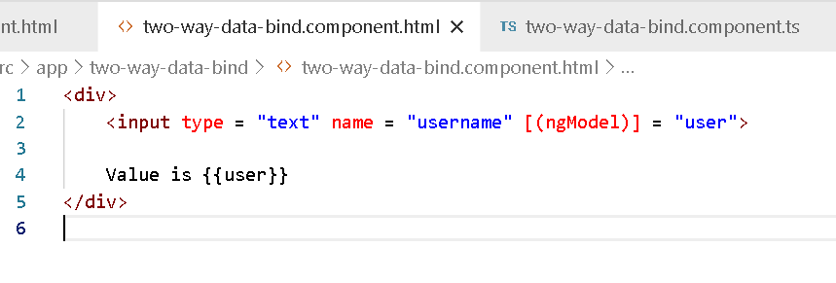

You will get below error when use [(ngModel)]

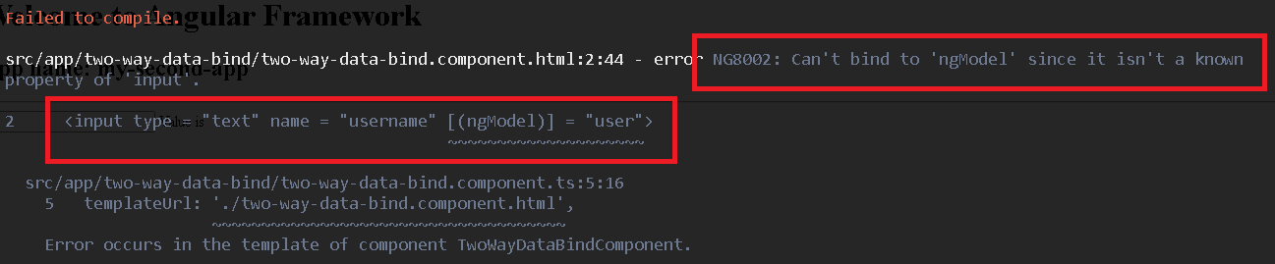

You must add *FormsModule* in imports of @NgModule({})

app.module.ts

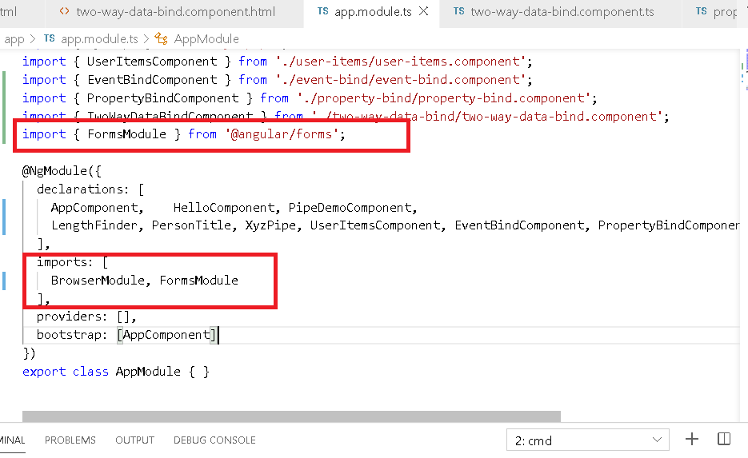

two-way-data-bind.component.html

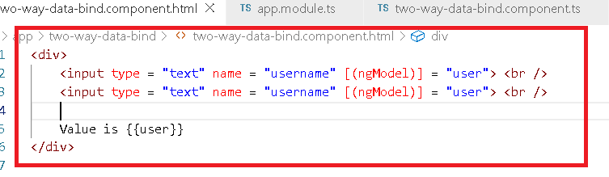

Output:

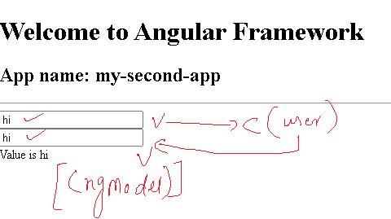

Advantage of using two-way-databinding is

1. You can directly update the property of the component from view so that you don’t need to have event bound to each data of view to the component through function.

i.e., <input (input) = “fun1(value)”>   
 <input (input) = “fun2(value)”>

2. You use two way databinding in case of form handling and also it helps in updating the view automatically when some data in components are updated the dependent property will be auto-updated because in two way databinding the data flows in both direction.

3. Form validations can be done where when use sends the data to the component the same data can be validated in the view

All these types of databinding makes data to flow either from view to component or component to view, but there are two more types of databiding where data can flow between the components.

Component interacting/communication

Here you can pass the data from one component to another component, we have two types of component here

1. parent component: enclosing component of another component
2. child component: a component nested inside another component.

You can use two types of decorators here

1. @Input(): Where data flows from parent to child
2. @Output(): Where data flows from child to parent

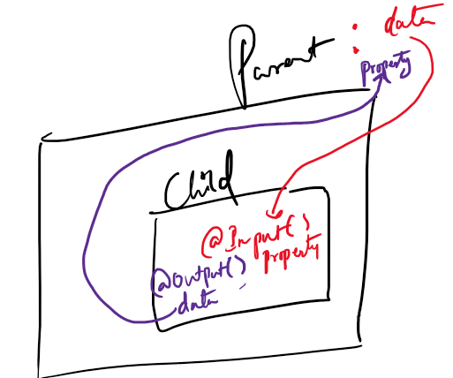

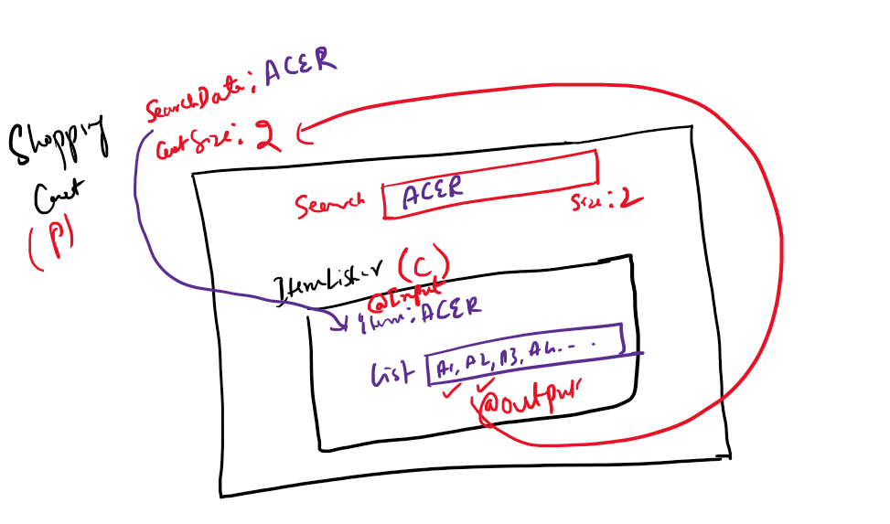

In a shopping care search box will be in parent component that receives the item to search and parent component will also have size to show the number of items selected, another component ItemLister will be a child that receives the value from parent to search and lists those items, when you select the item that will be updated to the size of the cart.

@Input() Demo

Here we will create a parent component called user-list(P) and a child component user-item(C) which displays the user details passed from user-list.

Note: child components are nested inside parent component.

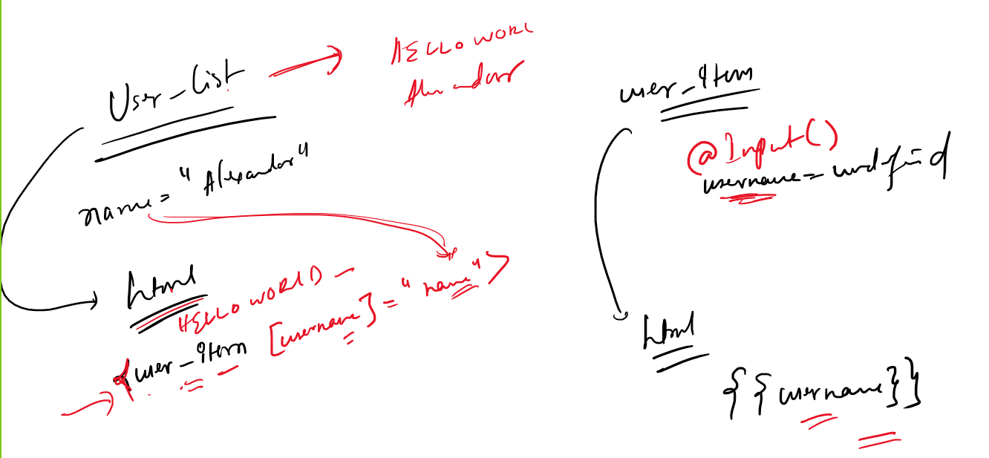

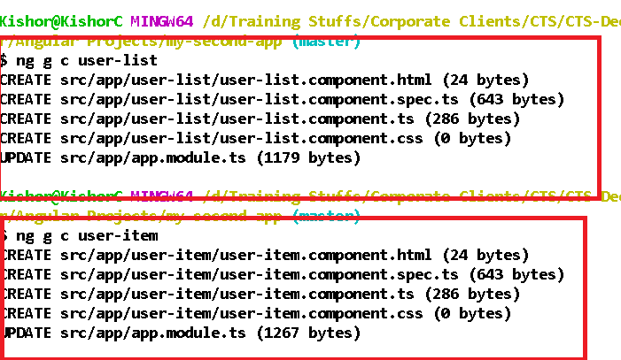

Add user list to the root component

app.component.html

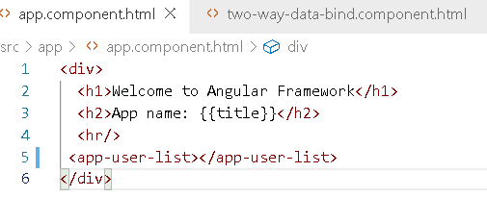

user-list.component.ts

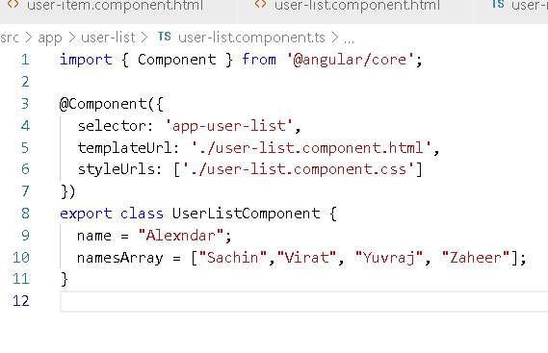

user-list.component.html

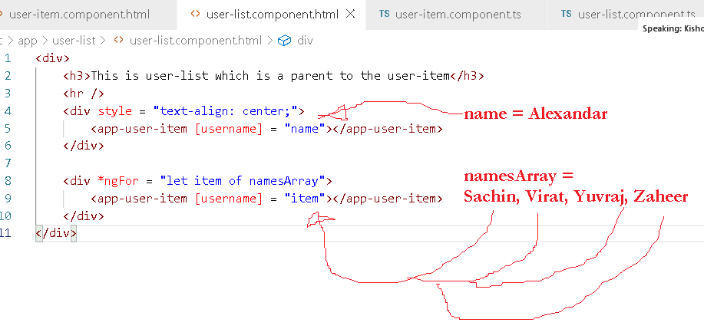

user-item.component.ts

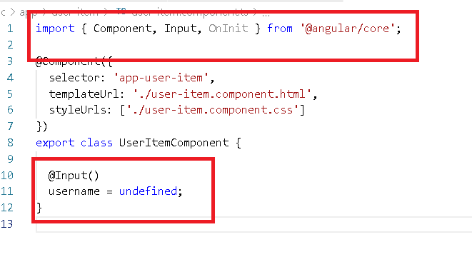

user-item.component.html

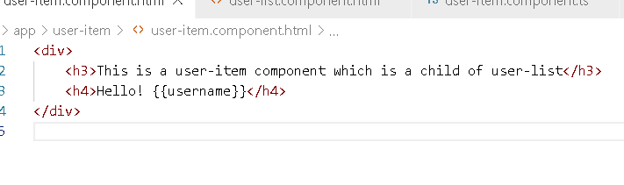

Output:

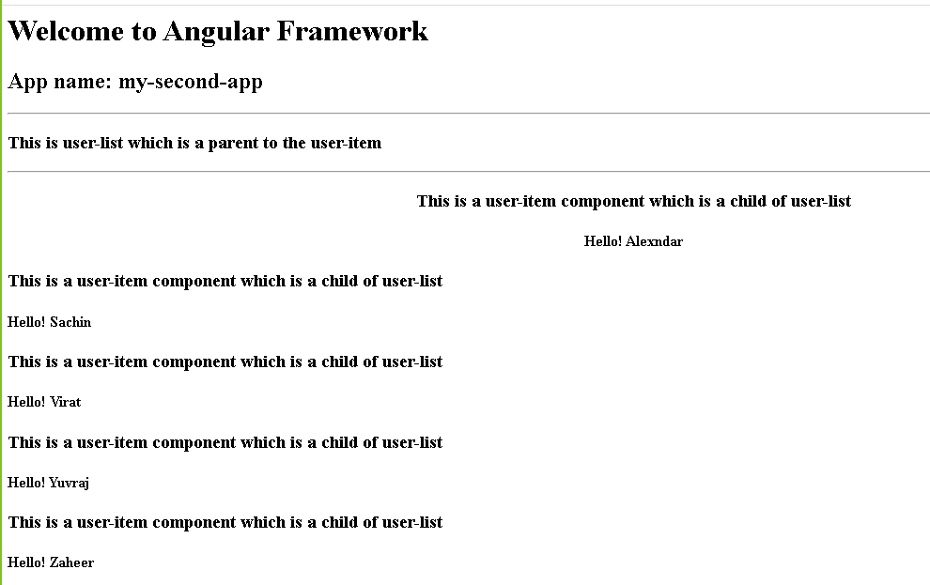

Note: [property]: it is used for DOM as well as component property binding, in DOM we use DOM properties like disabled, hidden, innerHTML and so on. Whereas in component property binding we use property of the child component, i.e., username if user-item

@Output():

It is used to pass child component values to the parent component, this is done as a event binding where you bind property of child component that is of type EventEmitter

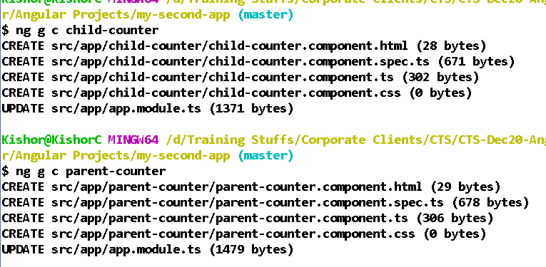

Add parent counter component to the root component

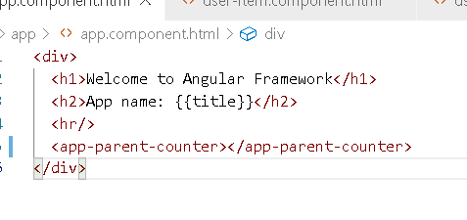

parent-counter.component.ts

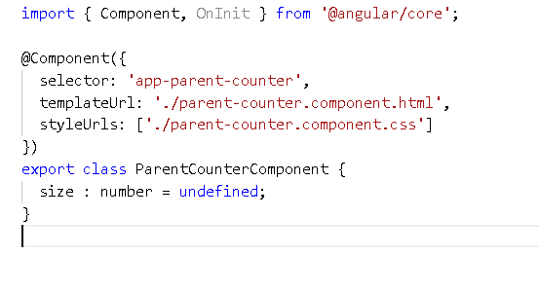

parent-counter.component.html

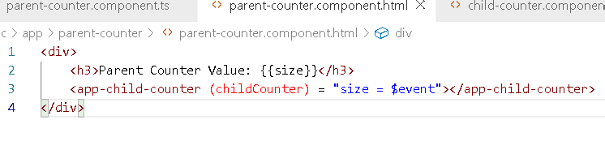child-counter.component.ts

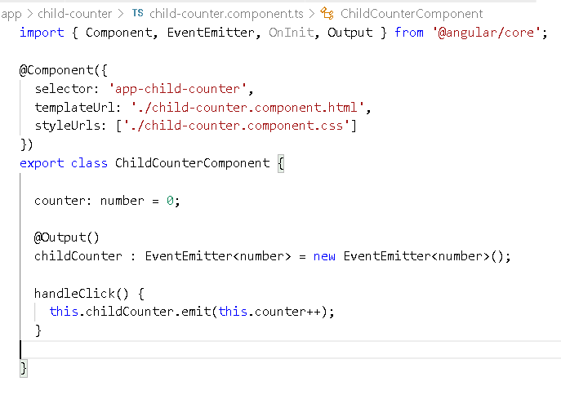child-counter.component.html

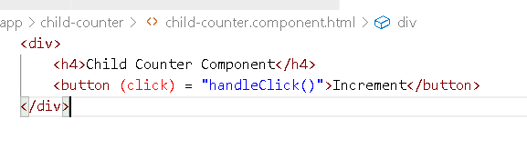

Output:

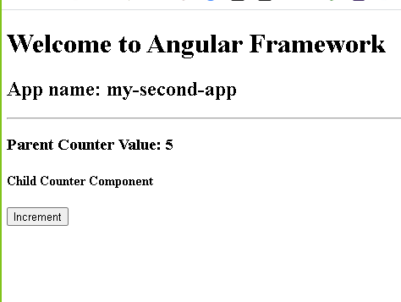

Note: @Output is mentioned on EventEmitter variable, that generates an event, $event is an event object that will have the value emitted by the event emitter property, so you must use child component event emitter property like a event binding.

<child (eventEmitterProperty) = “parentProperty = $event”>

Note: You can emit any complex object instead of number, string, boolean.

Let us try to emit a complex data from child and pass to parent

parent.component.ts

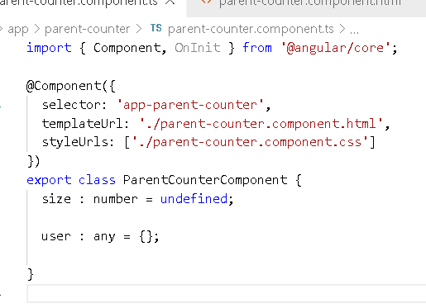

parent.component.html

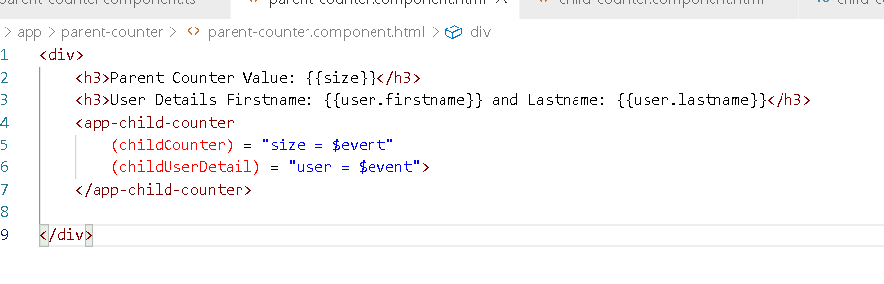

Note: childUserDetails generates user object & childCounter generates number

child-counter.component.ts

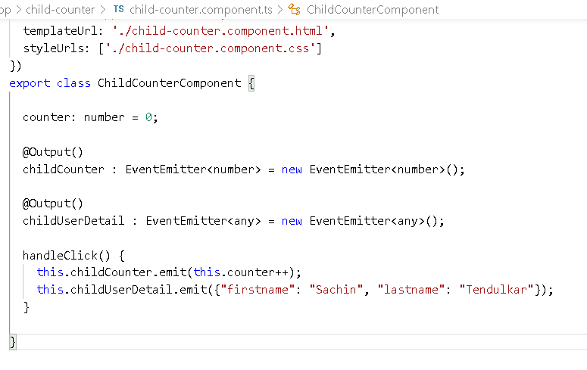

In the above code same handleClick generates event through childCounter & childUserDetails, event generated from childCounter is assigned to size & childUserDetails is assigned to user property of parent-counter

child-counter.component.html

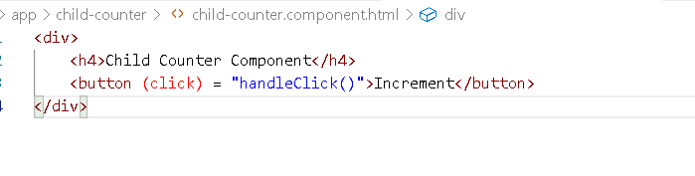

Output:

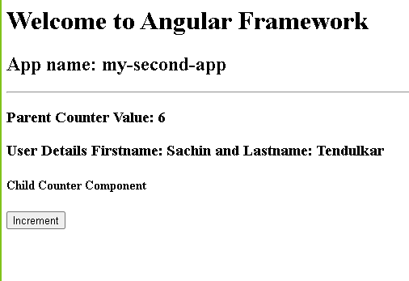

Exercise:

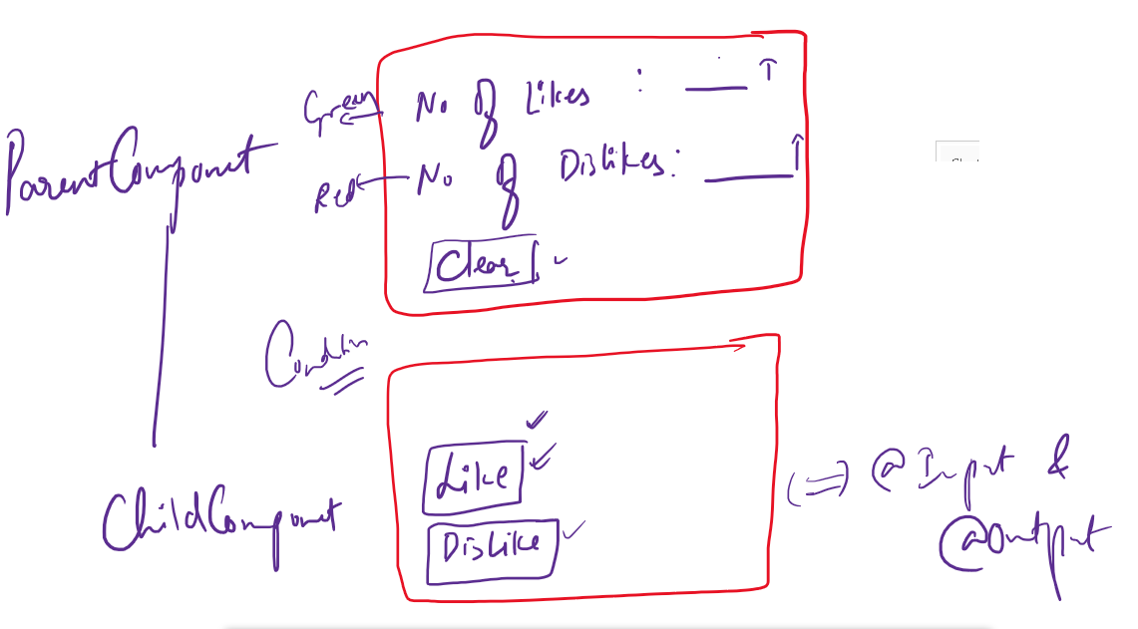

Condition: After clicking clear the like and dislike should start from the beginning

Angular Forms:

It uses ngForm to handle the data entered in HTML and submit to the components.

ngForm is an angular directive part of FormsModule this can hold all the form data in a single name

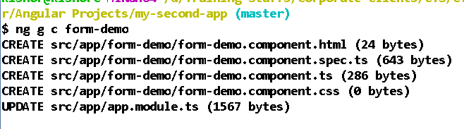

form-demo.component.ts

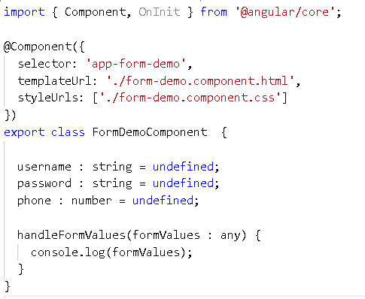

form-demo.component.html

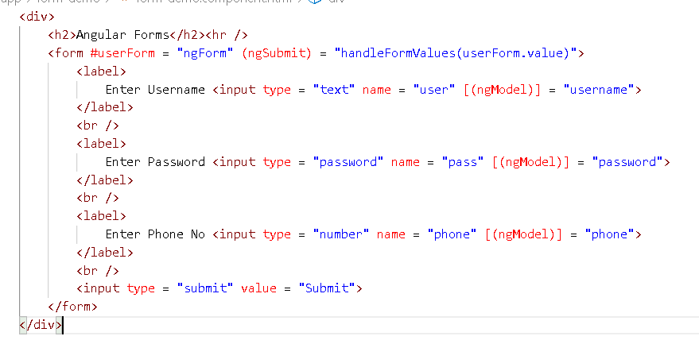

Output:

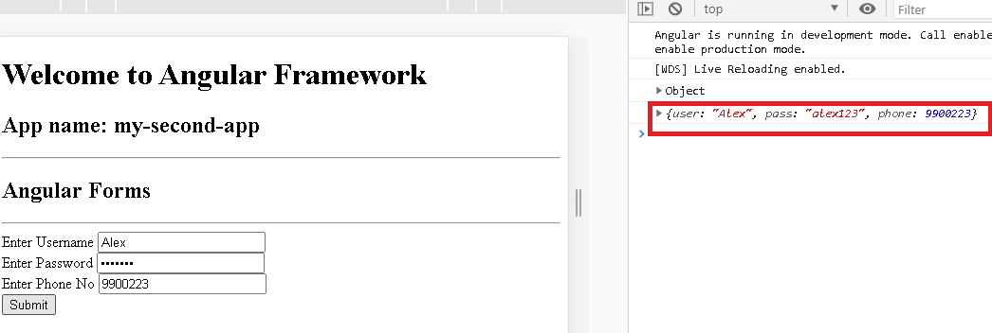

Form Validation:

ngForm gives some inbuilt properties where you can extract the form values, validate the form inputs with some properties.

form-demo.component.html

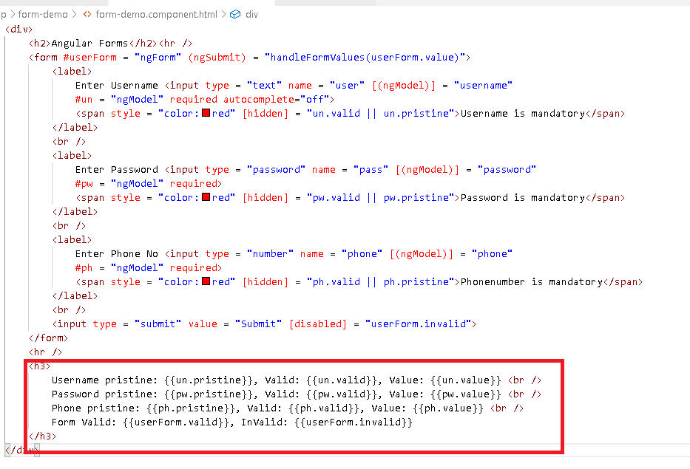

Pristine will be true if control is not modified

No changes in the form-demo.component.ts

Output:

